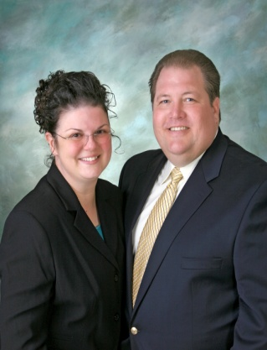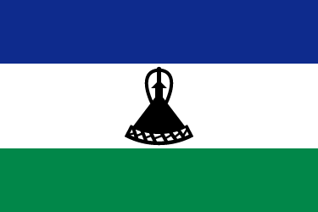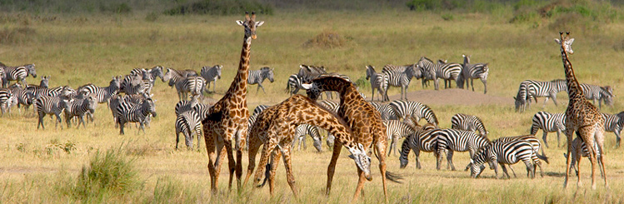 2nd Qtr. 2011-LESOTHO NEWS & UPDATE Official publication of the United Pentecostal Church International/Foreign Missions Division 8855 Dunn Road, Hazelwood,MO 63042
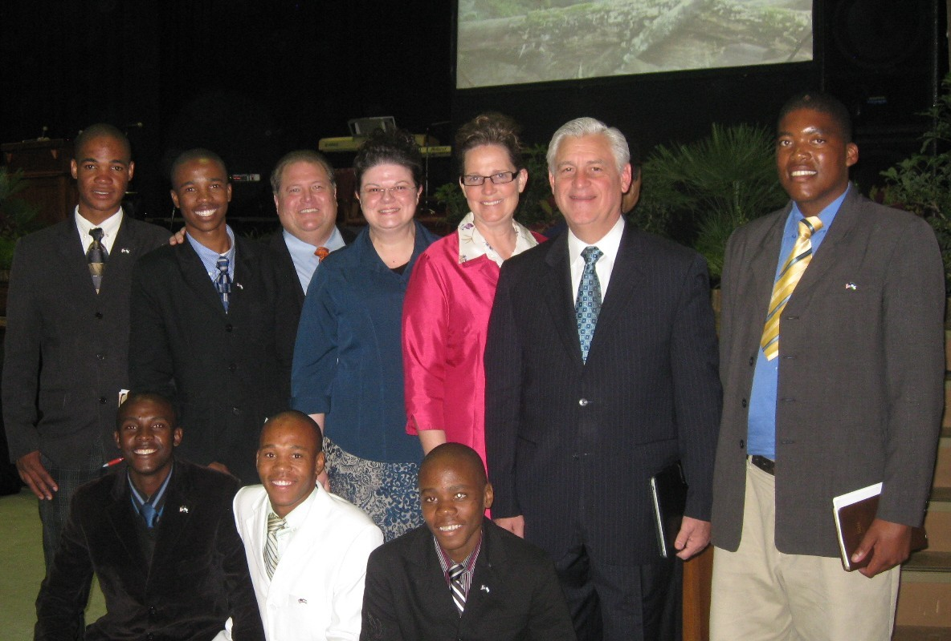
Rev. & Mrs. David K. Bernard, General Superintendent UPCI ministered in Bloemfontein, RSA near (1 ½ hour) Lesotho.
Recently we brought some LSO Bible Students & leaders to attend South Africa-UPC Gen Conference. Bro. & Sis. Bernard was the Special Guest Speakers! The Lord richly anointed and blessed their ministry! Bro. J. Smith & the RSA brethren are doing a good work. We have 14 new students enrolled in Bible School, Pray for their ministry!

A Special Thank you to Bro. Cox & Bro. Harper, LA Dist. for the project offering to assist our field in completing some major projects that we intended to complete before our next deputation! To all of our Faithful Partner-In-Missions; Thank You & God bless you for your Prayers & Sacrificial Giving! It is your dedication and commitment to building the Kingdom of the Lord, which allows us to reach Lost Souls in Africa! We pray that the Lord richly blesses you for your SUPPORT! Please pray the SUPPORT continues! Rev. & Mrs. D. A. Kline Email:missionarykline@aol.com webpage: http://kline.foreignmissions.com
PLEASE KEEP THE KLINE FAMILY IN YOUR PRAYERS!

